
SCHOOL OF ENGINEERING & TECHNOLOGY
Department of MCA
ACADEMIC YEAR: - 2024-25(ODD SEM.)

EventEase

An Event Management Website
By
Sarvesh Kolapkar
& Sagar Kirpekar

Project guide Supervisor
Prof. Kamlesh Meshram Prof Abhijita Biswal
Head of Department Project Mentor



PCET's PIMPRI CHINCHWAD UNIVERSITY,
Sate, Maval, Pune-412106

Certificate

This is to certify that Mr. / Ms. _______________________________ bearing PRN No ____________________ of MCA _____________ semester ____ and Subject ________________________________ has satisfactorily completed Mini Project on _____________________________________________during the academic year _________________.

Signature of Guide Signature of HOD

Signature of Internal Examiner Signature of External Examiner

Acknowledgement
I would like to express my heartfelt gratitude to everyone who supported and guided me throughout this project. First and foremost, I sincerely thank my supervisor, Prof. Abhijita Biswal, for her constant encouragement, expert guidance, and valuable feedback at every stage of this project. Her knowledge and insights have been instrumental in shaping the quality and direction of this work.

I am also deeply grateful to Prof. Kamlesh Meshram for providing the essential resources and infrastructure required to carry out this project. The supportive environment and access to necessary tools were key to achieving the project’s objectives.

A special thanks to my colleagues and peers for their collaboration, ideas, and willingness to help whenever needed. Their teamwork and shared knowledge made the project journey both enriching and enjoyable.

I am extremely thankful to my family and friends for their unwavering support and motivation throughout this process. Their encouragement, especially during challenging times, kept me focused and determined to complete this work.

Finally, I would like to acknowledge and thank everyone who contributed directly or indirectly to the successful completion of this project. Your support and contributions have made this achievement possible.

Thank you.
Project Members: Sarvesh Kolapkar(27) & Sagar Kirpekar(18)

Table of Contents
Sr.no | Description | Page No
1. | Introduction:  - Background/Problem  Statement  - Objectives of the Project  - Scope of the Project  - Organization of the Report | 7-8
2. | Literature Survey/Review  - Overview of existing work  - Projects, or products reviewed  - Identification of gaps | 8-9
3. | System Analysis  - Requirements Specification  ○ Functional  ○ Non-functional  - Feasibility Study (Technical,  Economic, and Operational  Feasibility)  - Tools and Technologies Used | 9-11
4. | Design  - System Architecture  - Diagrams (e.g., Use Case,  Class, Sequence, ...) | 11-12
5. | Implementation  ● Description of  Modules/Components | 13-16
 | ● Screenshots of the Application/System (if applicable)
6. | Testing  - Test Cases and Testing  Methodology  - Results of Testing  - Bug Fixes/Issues Resolved | 17-18
7. | Results and Discussion  - Outcomes of the project  - Comparison with existing  solutions (if applicable)  - Challenges Faced | 18-20
8. | Conclusion and Future Scope  - Summary of the work  - Limitations  - Future Enhancements | 20-21
9. | References | 21

Abstract
- Problem Statement
Traditional event management involves manual processes that are time-consuming and prone to errors. There is a need for an efficient, automated system to simplify event planning and management tasks.
- Objectives of the Project

- Develop a website which will help easily connect event organizers and vendors.

- This project aims to solve the problems faced many people while organizing any event & help many vendors get clients.

- Help service providers and vendors get clients for their services.

- Set budget and track the expenses throughout the process of event.

- Allow users to leave feedback and reviews for vendors and share their experiences with future users.

- Methodology

- Technology:
    - For Frontend: HTML, CSS, JS, flask,.etc
    - For Backend: Python, MYSQL,.etc

- Step-by-step process
- Gathering the requirements and design the architecture of the website.
- Design each and every page which will be included in the website.
- Develop the frontend of the website using html, css, and js.
- Develop the backend of the website using python.
- Test the working of the website to ensure everything works as expected.
- Debug any issues found during testing and make necessary changes.
- Deploy the website.
- Key Outcomes
EventEase delivers a functional event management system with features such as secure login, event creation and updates, user registration, and an admin dashboard. It provides a scalable solution for event organization and paves the way for future enhancements, including payment gateways and data analytics.

Introduction

- Background / Problem Statement
  - Event management is a critical task in many sectors, ranging from corporate organizations to educational institutions. Traditionally, event planning and coordination are performed manually, involving tasks such as maintaining physical registers, managing participant information, and manually communicating updates. These processes are often prone to errors, inefficiencies, and delays.
  - To address these issues, there is a growing need for a centralized, digital platform that can handle the complexities of event management efficiently. A robust solution must enable organizers to create, update, and manage events while providing users with a seamless experience for registration and information access.

- Objectives of the Project
  - The primary objectives of the EventEase project are as follows:
  - To design and develop a user-friendly event management system.
  - To provide secure user authentication for both admins and participants.
  - To enable admins to create, manage, and track events effortlessly.
  - To allow participants to view event details and register online.
  - To centralize event-related data for easy access and future analytics.

- Scope of the Project
  - The scope of EventEase includes:
  - Event Creation and Management: Admins can create, update, and delete events.
  - User Registration: Users can register for events and receive confirmation.
  - Database Integration: A robust database (MySQL) stores and retrieves event and user data efficiently.
  - Responsive Design: The frontend, built using HTML, CSS, and Bootstrap, ensures accessibility across devices.
  - Future Expansion: The system can be enhanced with features such as payment gateways, notifications, and analytics.
  - The project is designed to cater to small to medium-sized organizations initially, with potential scalability for larger use cases.

- Organization of the Report
This report is organized as follows:
  - Chapter 1: Introduction
Provides an overview of the project, including the problem statement, objectives, scope, and report organization.
- Chapter 2: Literature Survey
Reviews existing systems and identifies gaps that the EventEase project aims to address.
- Chapter 3: System Design and Architecture
Describes the technical architecture, database design, and system workflows.
- Chapter 4: Implementation
Details the implementation of key modules, technologies used, and development processes.
- Chapter 5: Testing and Evaluation
Outlines the testing strategy, test cases, and results to ensure the system’s reliability.
- Chapter 6: Conclusion and Future Scope
Summarizes the project outcomes and suggests potential future enhancements.

Literature Survey/Review
- Overview of Existing Work
  - Event management systems are widely used to streamline the organization and coordination of events. Several existing platforms, such as Eventbrite and Cvent, offer robust features like event scheduling, ticketing, and attendee management. These tools are designed for large-scale events, focusing heavily on automation and analytics.
  - In addition, smaller systems like open-source event management tools cater to community-level events but often lack advanced features like customization, analytics, or integration options. Most of these platforms require extensive training or a steep learning curve, making them less user-friendly for non-technical users.
- Projects or Products Reviewed
  - Eventbrite: A leading event management platform known for its ticketing and marketing capabilities. It is ideal for large-scale, professional events but can be costly for smaller organizations.
  - Cvent: Offers advanced analytics and event customization but is primarily geared toward corporate use, with complex interfaces.
  - Open Source Event Management Tools: Examples include Event Espresso and RSVPify. While these tools are cost-effective, they often lack features like secure payment gateways or intuitive designs.
- Identification of Gaps
  - After reviewing these platforms, the following gaps were identified:
  - Cost Effectiveness: Most tools are expensive for small to medium-sized event organizers.
  - Ease of Use: Complex interfaces and a lack of user-friendly designs make it difficult for non-technical users to navigate.
  - Customization: Limited options for tailoring the system to specific needs, particularly for smaller organizations or niche events.
  - Scalability: Open-source tools often lack the infrastructure to support larger-scale events as they grow.
  - By addressing these gaps, the EventEase project aims to create a system that is affordable, easy to use, customizable, and scalable for a wide range of users.

System Analysis
- Requirements Specification
  - Functional Requirements
The functional requirements define the core functionalities of the EventEase system:
- User Authentication: Secure login and registration for users and administrators.
- Event Management:
  - Admins can create, update, delete, and manage event details (name, date, time, venue, description).
  - Users can view available events and register.
- User Registration Management:
  - Users can register for events and view confirmation details.
  - Admins can track registrations and participant information.
- Dashboard: Admin dashboard to display event statistics and manage operations.
- Non-functional Requirements
The non-functional requirements ensure the system's performance and reliability:
- Usability: The system should have an intuitive, user-friendly interface for both admins and users.
- Scalability: The system should handle an increasing number of users and events.
- Security: Data must be encrypted, and secure password handling should be implemented.
- Performance: The system should respond within 2 seconds for any operation.
- Compatibility: The platform must be accessible across multiple devices and browsers.

- Feasibility Study
  - Technical Feasibility
    - The system is built using well-supported and widely-used technologies like Flask (Python), MySQL, HTML, CSS, and Bootstrap. These tools ensure ease of development, scalability, and maintenance. The project team is familiar with these technologies, making implementation feasible.
  - Economic Feasibility
    - EventEase is cost-effective as it uses open-source tools, which reduce development and deployment costs. The system is designed to cater to small and medium-sized organizations, ensuring affordability for end users.
  - Operational Feasibility
    - The system meets the operational needs of users by simplifying event management. Admins can easily manage events, while users experience a seamless registration process. Its ease of use ensures quick adoption with minimal training.

- Tools and Technologies Used
  - Backend Development
    - Python Flask Framework: To build the backend application and handle server-side logic.
    - SQLAlchemy: For database interactions.
    - MySQL: A relational database used to store user and event data.
  - Frontend Development
    - HTML and CSS: For structuring and styling the application.
    - Bootstrap: To create a responsive and mobile-friendly design.
  - Development Tools
    - Visual Studio Code: For writing and managing code.
    - MySQL Workbench: For database design and management.
    - Git: Version control to track changes and collaborate effectively.

Design:
System Architecture
The system architecture for EventEase is a multi-tiered design that separates different concerns, ensuring modularity and scalability.
- Frontend:
  - Built using HTML, CSS, and Bootstrap to provide an intuitive user interface.
  - Includes pages like user signup/login, service provider signup/login, and service listing.
- Backend:
  - Developed using Flask, a lightweight Python web framework.
  - Handles user authentication, business logic, and routing requests.
  - Integrates with a MySQL database using SQLAlchemy for Object-Relational Mapping (ORM).
- Database:
  - A MySQL database is used to store information about users, services, and service providers.
- File Storage:
  - Uploaded files (e.g., service images) are stored in the static/uploads directory on the server.
- Communication:
  - The frontend communicates with the backend through HTTP requests.
  - Session management is used for secure user/provider login and data persistence.

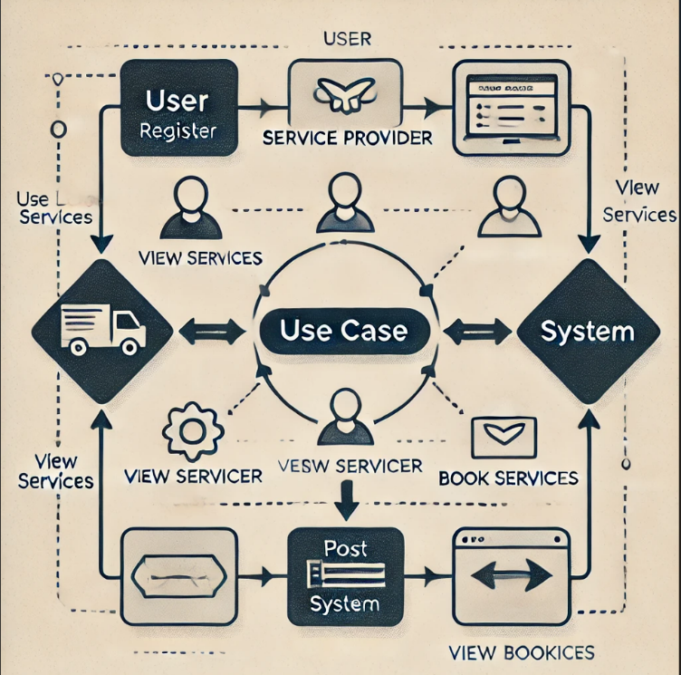

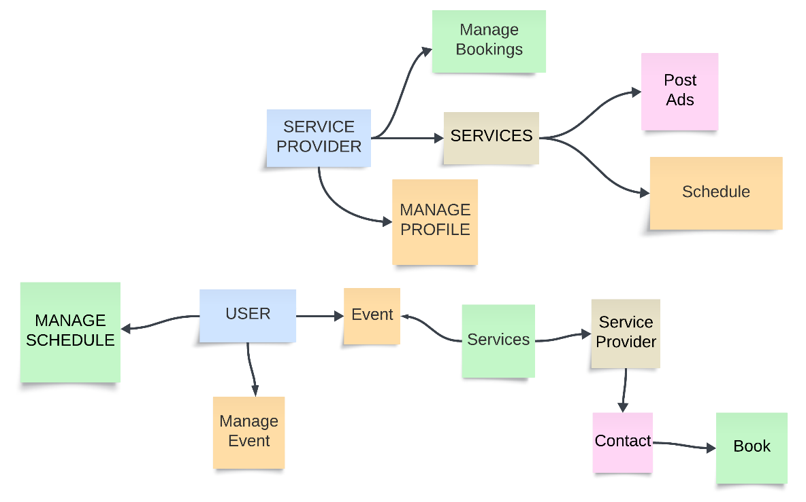

Implementation
- Description of Modules/Components
  - Authentication Module
    - Purpose:
Ensures secure login and registration for users and administrators.
    - Features:
      - Password hashing for security using libraries like werkzeug.
      - Role-based access (user/admin).
    - Process:
      - Users provide credentials via the frontend.
      - The backend validates the credentials and grants access.
  - Event Management Module
    - Purpose:
Enables admins to create, update, delete, and view events.
    - Features:
      - CRUD (Create, Read, Update, Delete) operations for event records.
      - Validation for event details like date and location.
    - Process:
      - Admin submits event details through a form.
      - The backend processes the data and updates the MySQL database.
  - User Registration Module
    - Purpose:
Allows users to register for events.
    - Features:
      - Event listing for users to browse available events.
      - Database entry for each registration with user and event IDs.
    - Process:
      - Users select an event and register via the frontend.
      - The backend stores the registration details in the database.
  - Dashboard Module
    - Purpose:
Provides an admin interface to monitor event registrations and statistics.
    - Features:
      - View participant lists for events.
      - Display key metrics like total registrations.
    - Process:
      - Admin accesses the dashboard through secure login.
      - The backend retrieves data from the database and displays it dynamically.

Code snippets:
Index.html

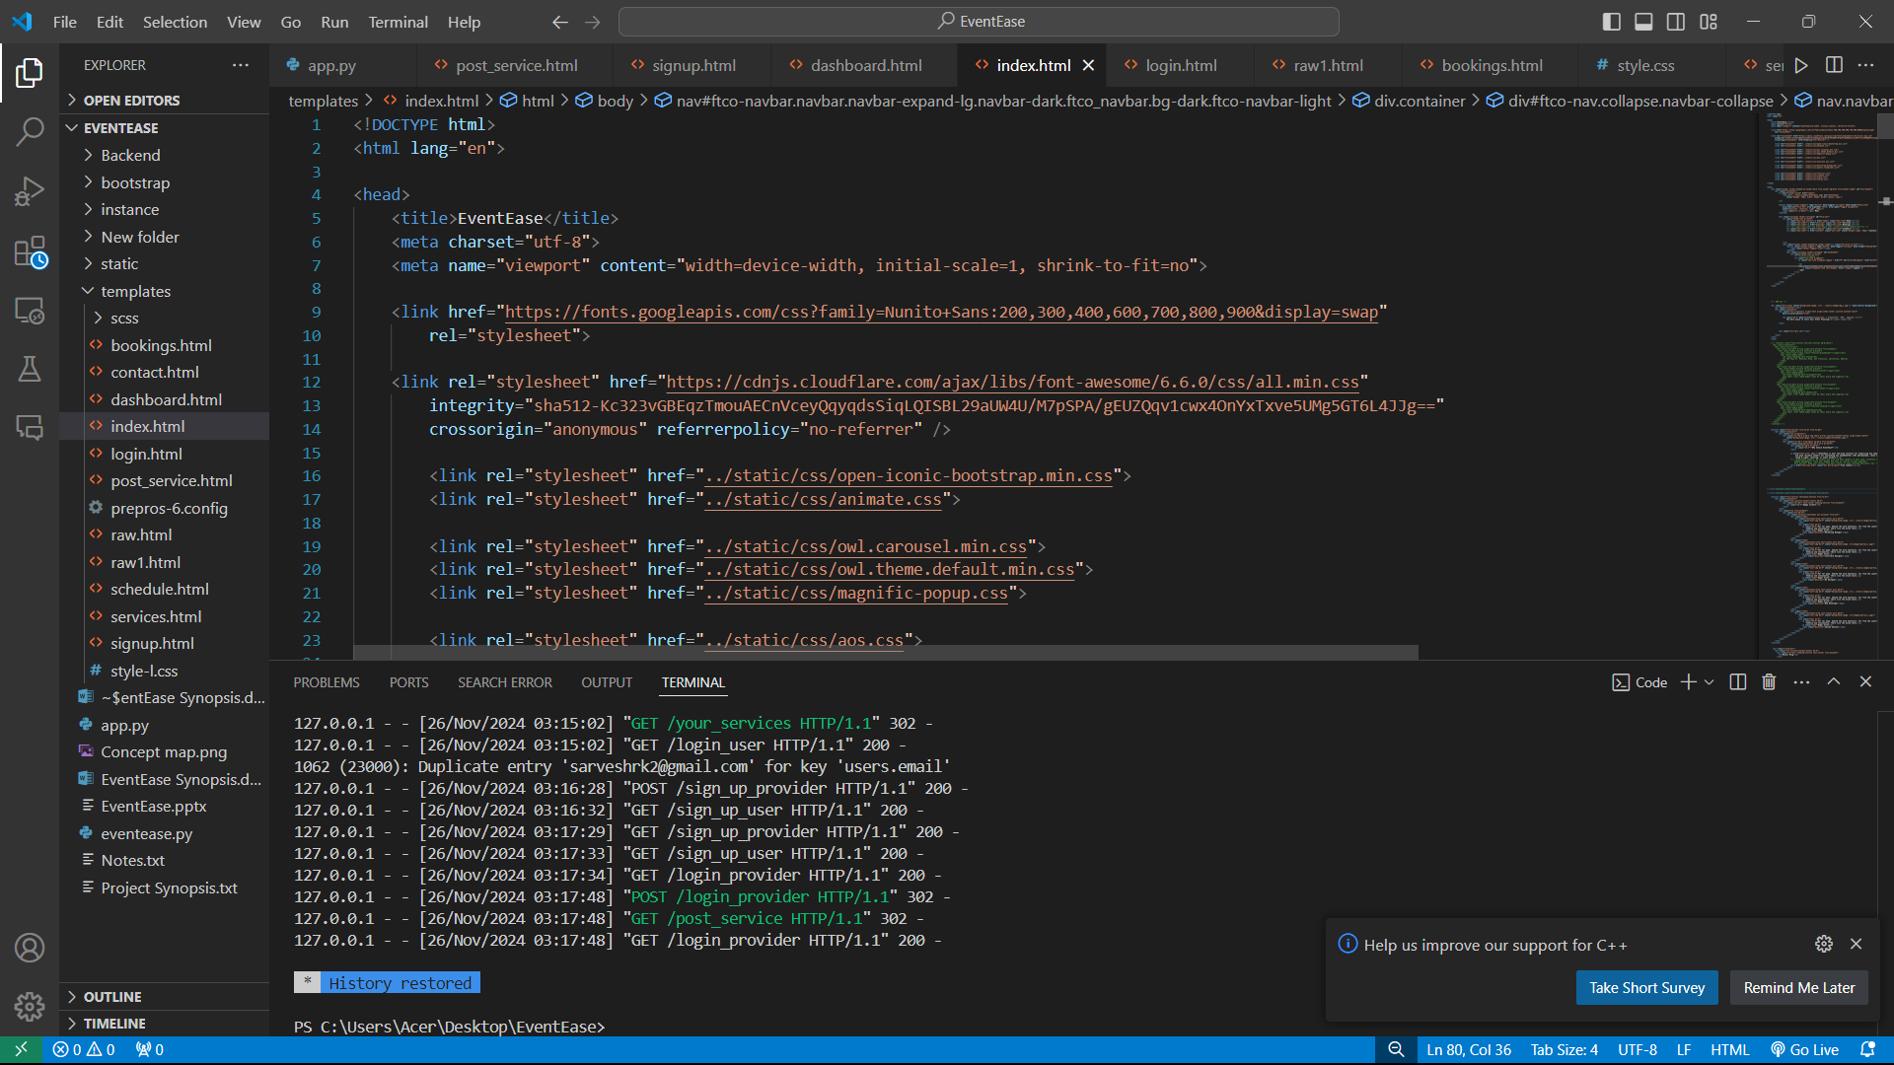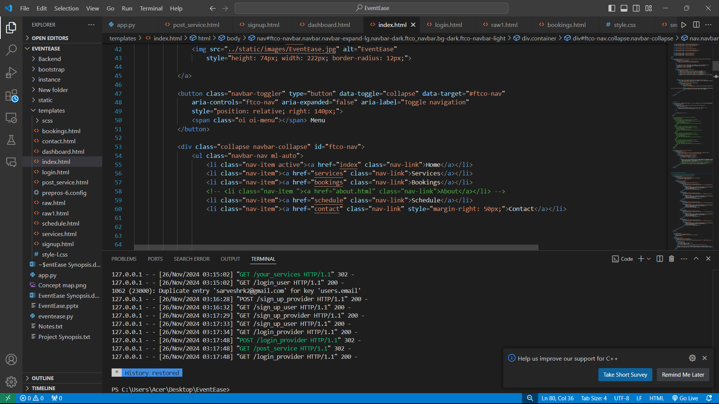

Login:
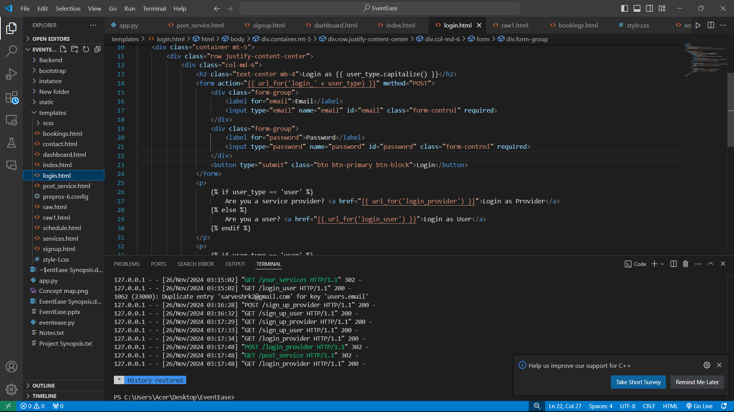

Backend:
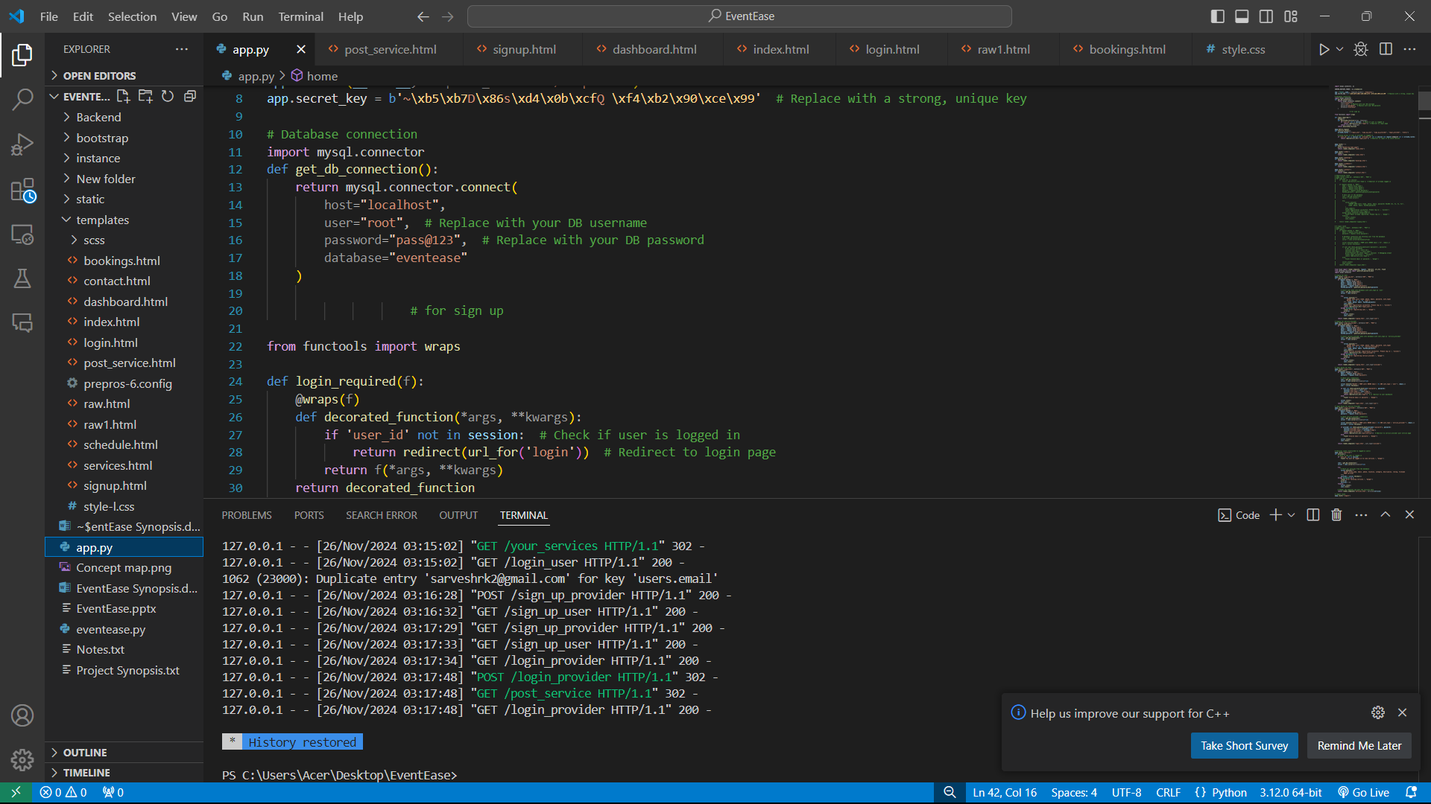

Testing

- Testing Methodology
The testing process followed the Black Box Testing approach, focusing on validating the functionality of the system against its requirements. Key types of tests conducted include:
  - Unit Testing: Ensuring each module (e.g., login, event creation) functions as expected.
  - Integration Testing: Testing the interaction between modules (e.g., event creation and database updates).
  - System Testing: Verifying the system’s overall functionality and performance.
  - User Acceptance Testing (UAT): Feedback from end-users to ensure the system meets their expectations.

- Sample Test Cases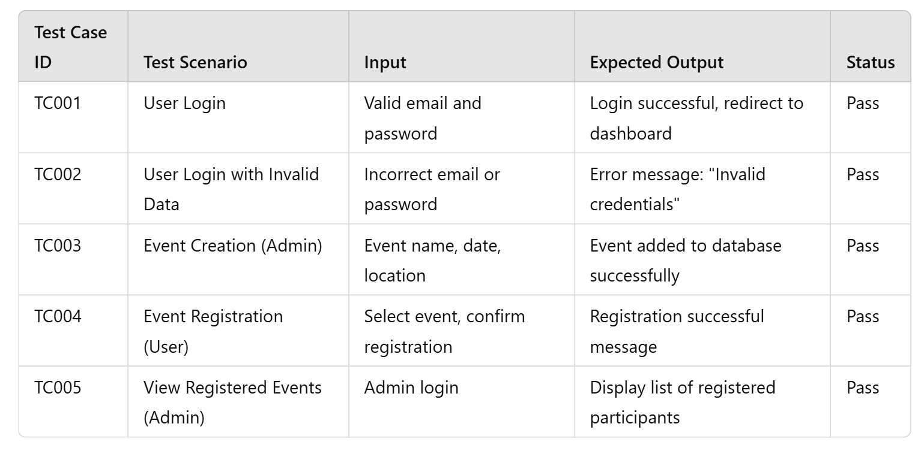

- Results of Testing
  - All key functionalities, including login, event creation, and user registration, were tested successfully.
  - Performance Testing: The system handled up to 100 simultaneous user registrations without significant lag.
  - Security Testing: Passwords were verified to be securely hashed, and sensitive data was protected.

- Summary of Results

- Bug Fixes / Issues Resolved

- Issue: Login page not redirecting correctly after successful authentication.
  - Resolution: Fixed by adding proper routing in the Flask app and debugging the session handling.
- Issue: Registration form validation not working for empty fields.
  - Resolution: Added client-side JavaScript validation for mandatory fields.
- Issue: Event dates were being stored in an incorrect format in the database.
  - Resolution: Updated the backend to handle date formatting before saving to the database.
- Issue: Dashboard performance lagging with large datasets.
  - Resolution: Optimized database queries using indexing and limiting data retrieval.

Outcomes of the Project

The EventEase system successfully achieved the following outcomes:
- Efficient Event Management
  - Admins can easily create, update, and delete event records. Users can view and register for events without technical difficulties.
- User-Friendly Interface
  - Designed with simplicity and responsiveness using HTML, CSS, and Bootstrap. Tested across devices to ensure compatibility and ease of use.
- Data Management and Security
  - Event and user data are securely stored in a MySQL database. Passwords are encrypted using robust hashing techniques.
- Scalable Design:
  - System can handle an increasing number of events and registrations with minimal impact on performance.

Comparison with Existing Solutions
EventEase was compared against popular event management platforms such as Eventbrite and Cvent.
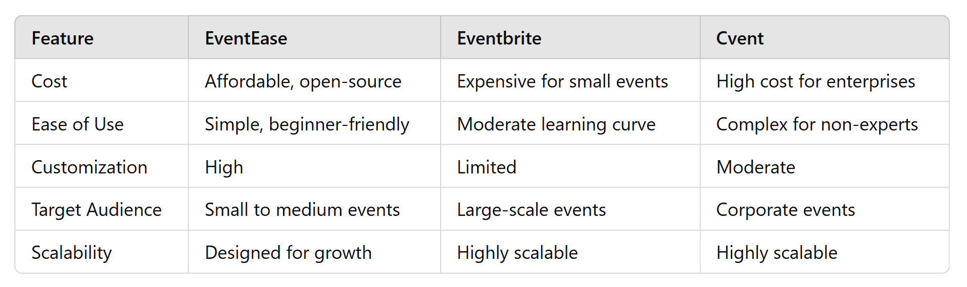

Key Advantage of EventEase:
- Focuses on small to medium-sized organizations that need cost-effective and customizable solutions, making it more accessible than competitors.

Outcomes of the Project:
The primary outcome of the EventEase project is the development of a platform where users can easily browse and book services offered by various providers. We successfully implemented user registration, login, and service browsing functionalities. Service providers can also register, log in, and post their services, creating a dynamic ecosystem. The system aims to bridge the gap between service seekers and providers, offering a seamless experience for both parties. Overall, the platform works as intended, meeting the core objectives set at the beginning of the project.
Comparison with Existing Solutions:
When compared to existing service booking platforms, EventEase offers a simpler, more user-friendly interface. Many popular platforms have complex navigation and are overloaded with unnecessary features. In contrast, EventEase focuses on the basics: easy navigation, simple registration processes, and clear categorization of services. While it may not have as many advanced features as some bigger platforms, it stands out for its simplicity and ease of use. This focus on user experience ensures that both users and service providers can engage with the platform without feeling overwhelmed.
Challenges Faced:
During the development of EventEase, we encountered several challenges. One major issue was ensuring a smooth user authentication process for both users and service providers. Managing different types of user roles and securely handling their data required extra effort. Another challenge was implementing a system that can easily scale to handle increasing data as more users and service providers join. Additionally, integrating file upload functionality for service providers to post service images created some hurdles in managing file storage and validation. Despite these challenges, we were able to overcome them with persistent debugging and adjustments to the backend, ensuring a robust platform.

Conclusion and Future Scope

Summary of the Work:
- Developed a platform where users can discover and book services from various providers.
- Implemented key features like user and service provider registration, login, service posting, and browsing.
- Focused on simplicity and user-friendly navigation.
- Completed core functionalities, offering a valuable tool for service management and booking.
Limitations:
- The platform currently lacks advanced features like:
  - User reviews for services.
  - Payment gateway integration for direct booking.
  - Advanced filtering options for services.
- Scalability could be a concern, especially in handling high traffic or large amounts of data.
- User authentication and session management could be optimized for better security and performance.
Future Enhancements:
- Rating and Review System: Implement a feature for users to rate and review services, aiding better decision-making.
- Payment Gateway Integration: Add payment functionality for users to book services directly through the platform.
- Advanced Search Filters: Include features like location-based filtering and categorization of services for a better browsing experience.
- Scalability Improvements: Optimize the platform for higher traffic and ensure smooth performance with a growing number of users and service providers.
- Security Enhancements: Improve user authentication and session management for better data security and smoother operations.

References
- Author, A. A., Author, B. B., & Author, C. C. (Year). Title of the Book or Article. Publisher. DOI/Publisher Link (if applicable).
- Author, D. D. (Year). Title of the Article. Journal Name, Volume(Issue), Page Numbers. https://doi.org/xxxxxx (if applicable).
- Lastname, F. F. (Year). Title of the Website or Online Article. Retrieved from URL.
- Name of the Organization or Group. (Year). Title of the Report/Document. URL or DOI (if applicable).
- Smith, J. (Year). Introduction to Event Management Systems. Tech Press. https://techpress.com/intro-to-event-management

Example References:
- Jones, M., & Harris, R. (2023). Web Development for Beginners: A Guide to Building Dynamic Websites. Web Publishers.
- Brown, P. (2022). Building User-Friendly Interfaces for Event Management Platforms. Journal of Web Development, 15(4), 45-58. https://doi.org/10.1234/jwd.2022.045678
- WebDev Studio. (2024). How to Build a Robust Event Booking System. Retrieved from https://www.webdevstudio.com/event-booking-system
- W3C. (2022). HTML5 Specification. Retrieved from https://www.w3.org/TR/html5/
- Smith, J. (2021). Introduction to Event Management Systems. Tech Press. https://techpress.com/intro-to-event-management

